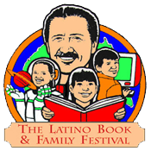

Maestro Award

Latino Literacy Now is seeking nominations for the Maestro Award. A committee comprised of community leaders will be selecting the recipients. The award recipients will be honored at the Latino Book and Family Festival on September 15, 2018 at MiraCosta College in Oceanside, CA. Deadline to submit a nomination is August 15, 2018 at 5:00 pm. The recipients will be notified by August 15, so they can have enough time to plan to be at the event to accept their award.

Nomination Criteria: Do you know of someone who is an exemplary teacher who goes above and beyond the classroom, is creative, serves as a mentor, is an educational activist, and is committed to multicultural education? Perhaps they are also a lifelong learner, a leader, and an innovator?

If so, these are the qualities we believe would define the next Maestro Award recipient.

Your Name:________________________________________________________________________________

Email:_______________________________________Phone:_______________________________________

Name of Nominee:__________________________________________________________________________

Address:__________________________________________________________________________________

Email:_______________________________________Phone:_______________________________________

Please tell us why you feel your nominee deserves this award?

Is there anything else that demonstrates why this individual should be recognized with the Maestro Award?

